**CSCE 5533 Advanced Information Retrieval**

**Homework 4**

**By: Tong Yu**

**Introduction:**

The purpose of this homework is to create a World Wide Web interface can be globally accessible to all the users. The homepage of this website will accept an user input. The retrieve program will create a result page to display the top 10 documents in order. When the user clicks on the link on the result page, it will navigate the user to the target website’s url.

**Implementation:**

I created a cgi program by calling a C++ program from PHP script. I initially go through the step by step instruction from the class website to set up the website. After the basic instruction, I modified the html and css to make the website look more professional. I made some minor adjustments on the c++ program from the homwork3 to fit this homework. I named this website ‘YuGo’. The homepage is designed based on how google search looks like. The whole website’s design is all implemented using html and CSS.

**Website Url:**

<http://www.csce.uark.edu/~tyu/yugo.php>

**Required Files:**

* retrieve.cpp
* yugo.php
* dictionary.txt
* posting.txt

**Compile C++ program:**

g++ -std=c++0x -o retrieve.exe retrieve.cpp

**APPENDIX:**

* This is what home page looks like

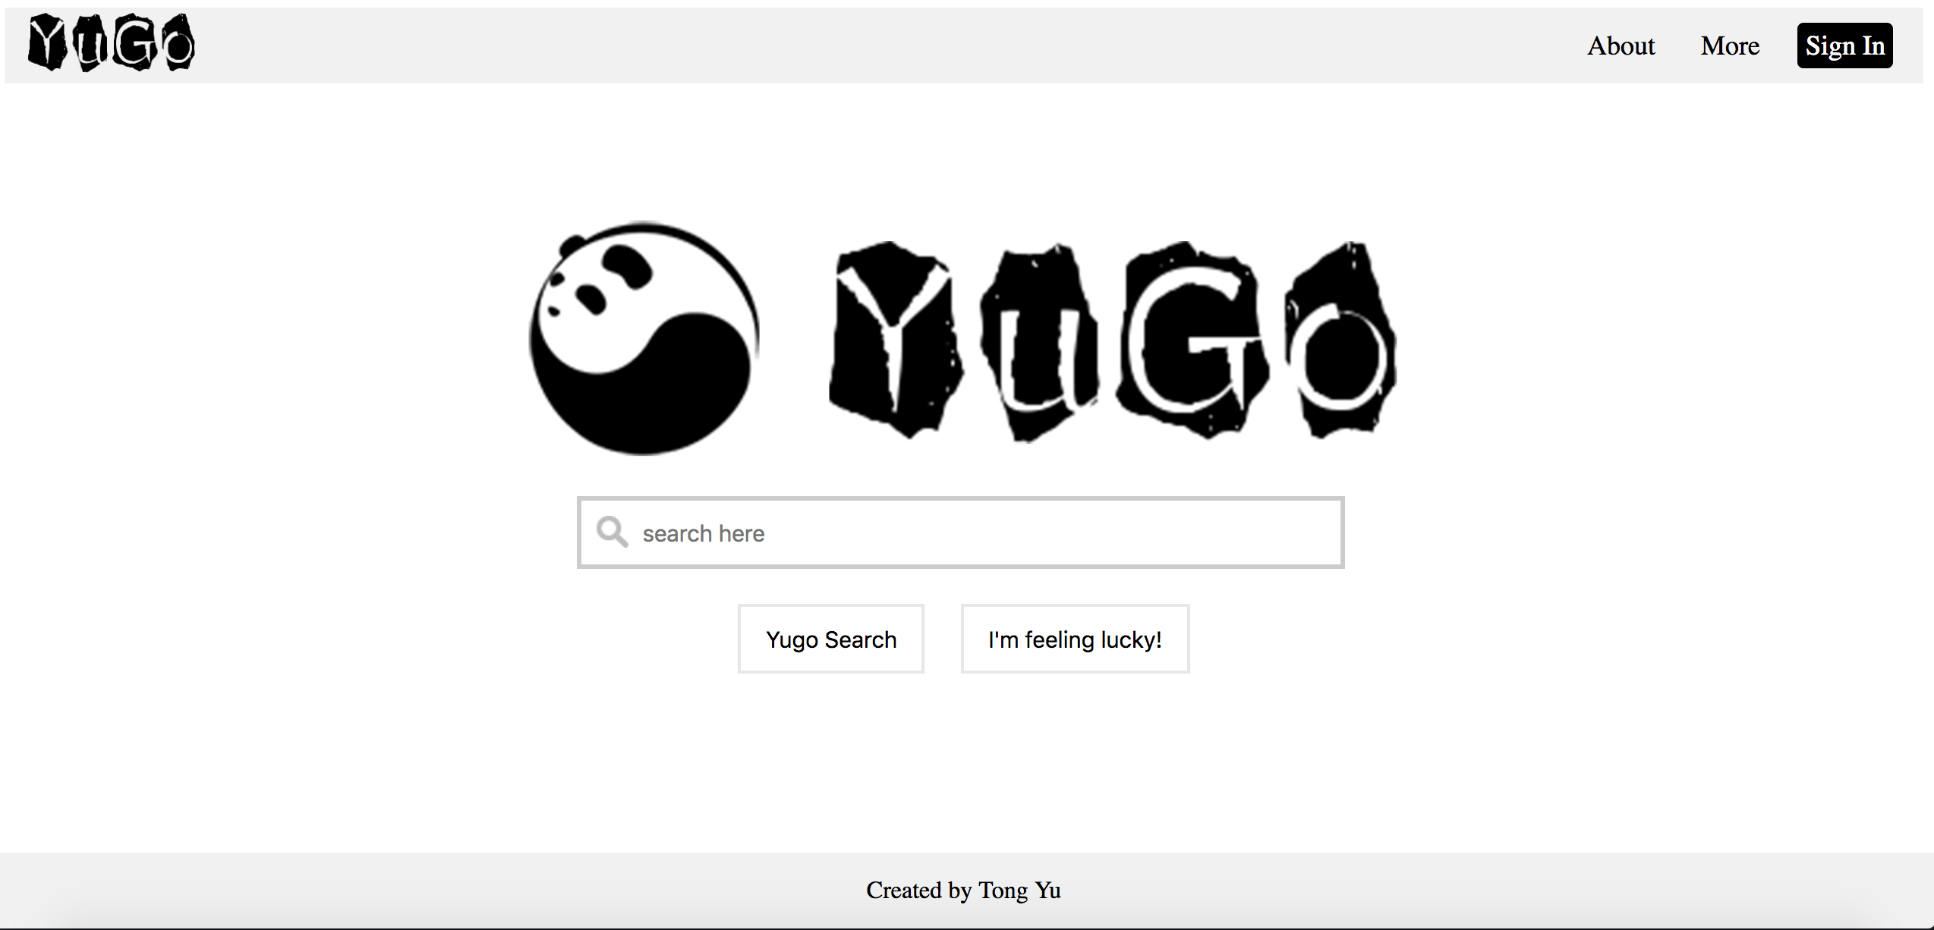

* paradigms

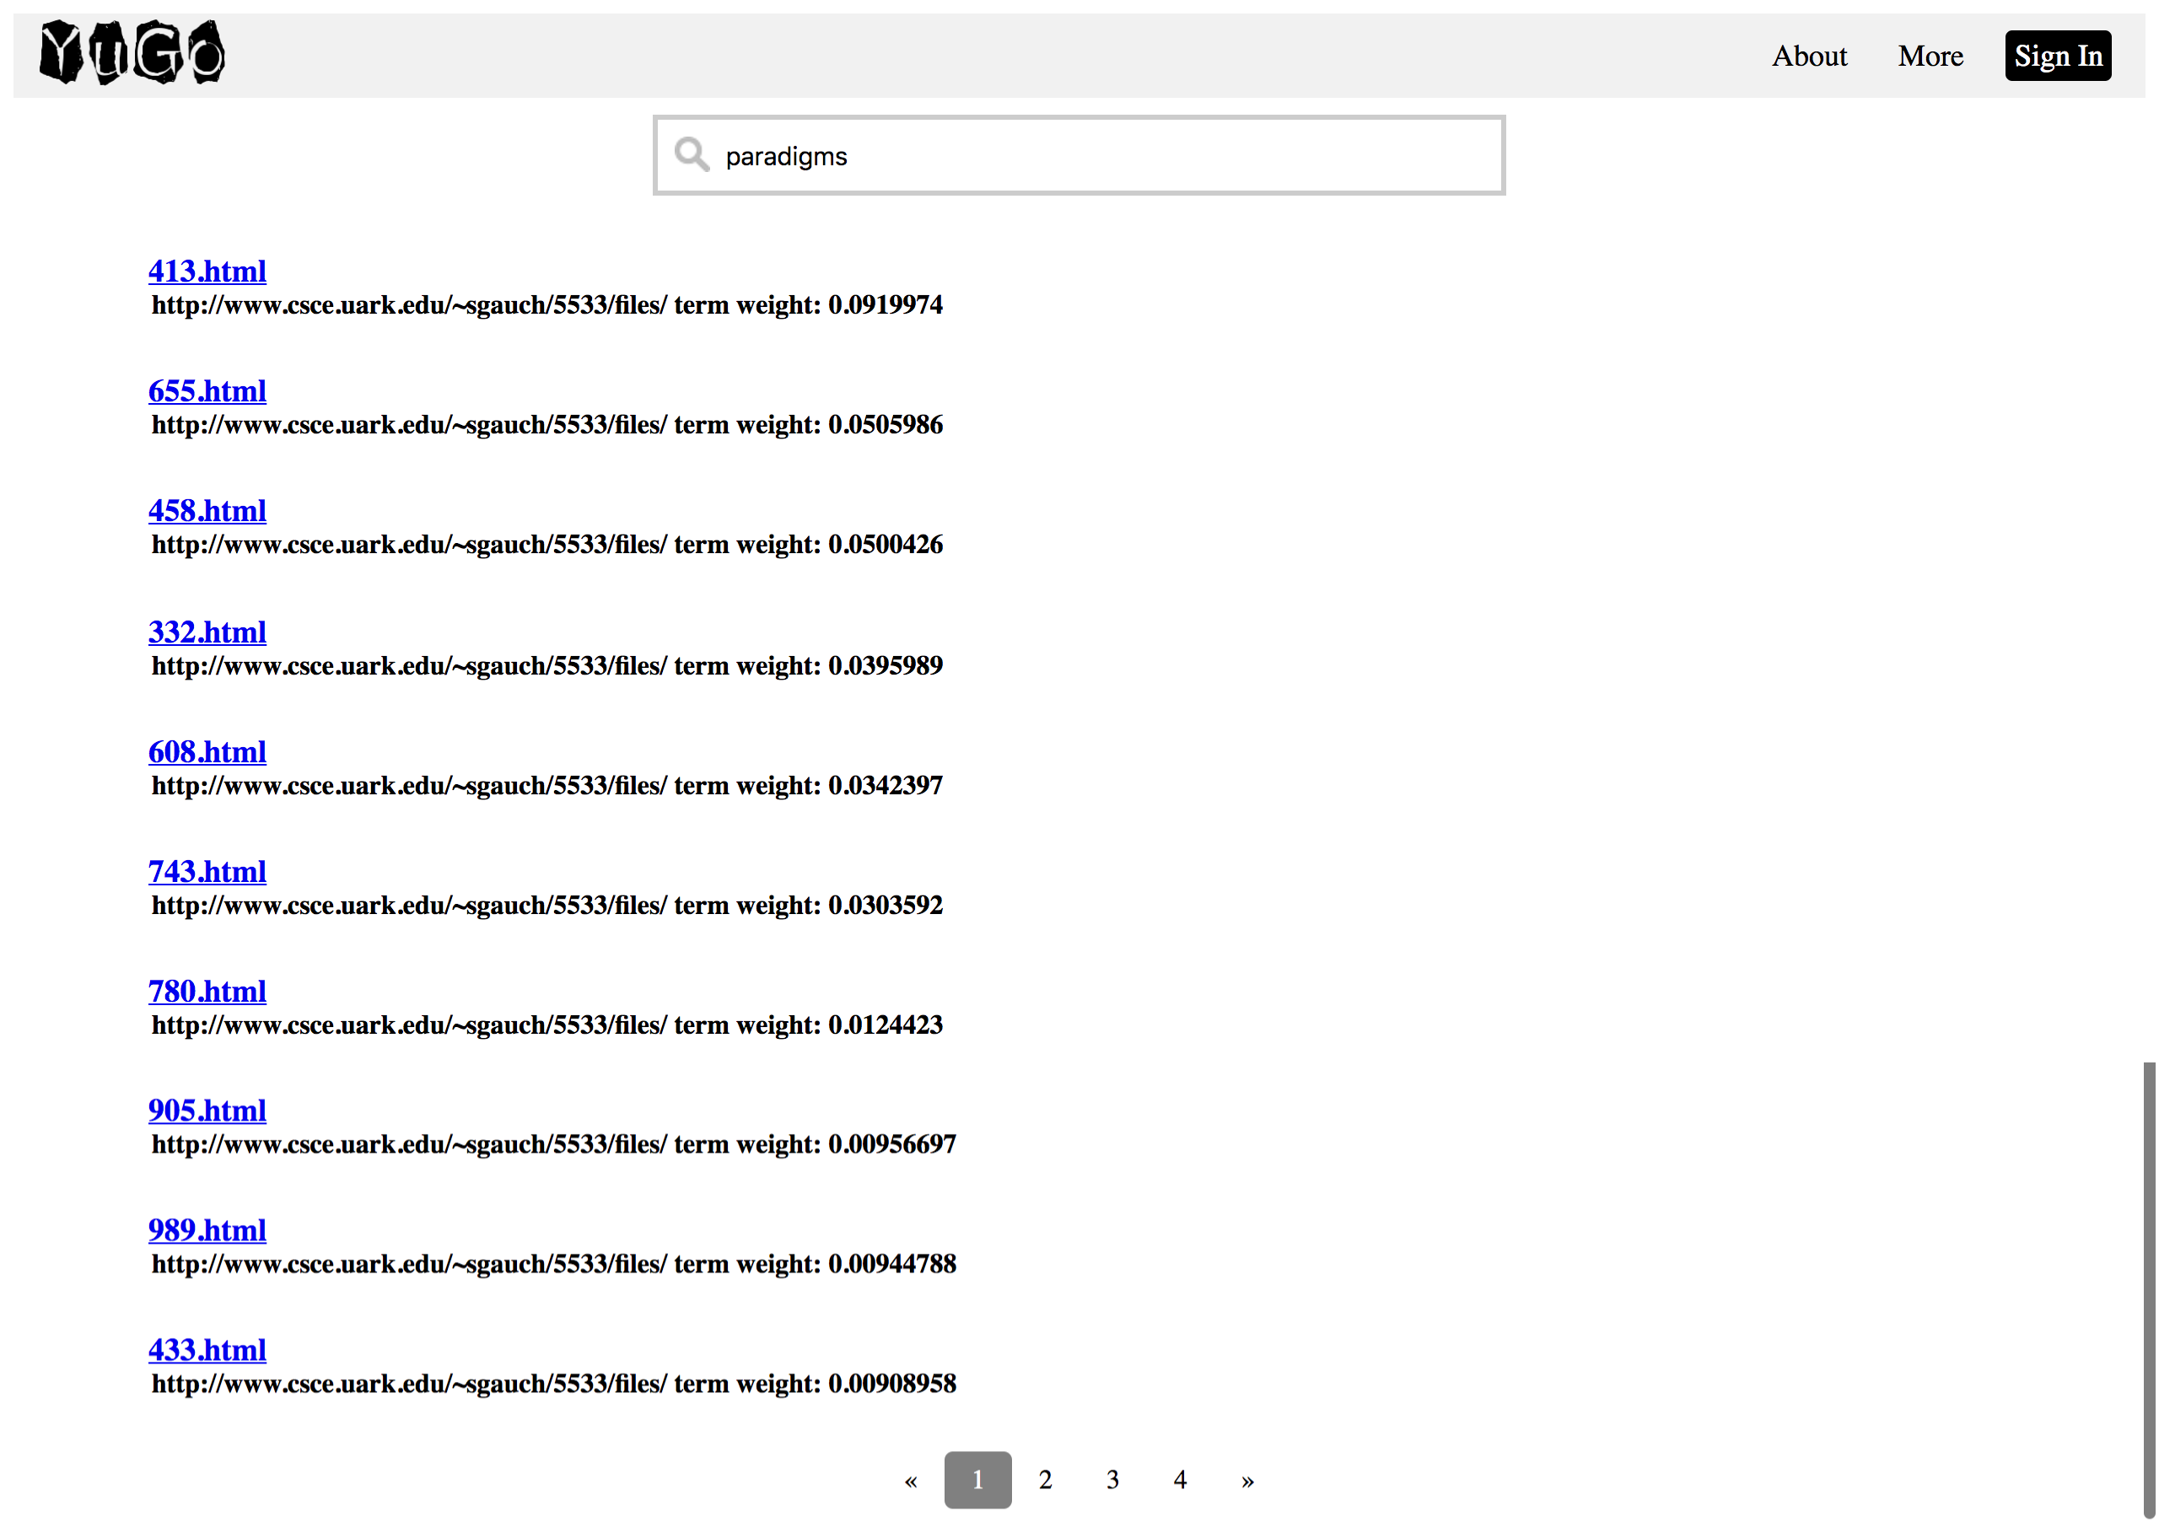

* algorithms

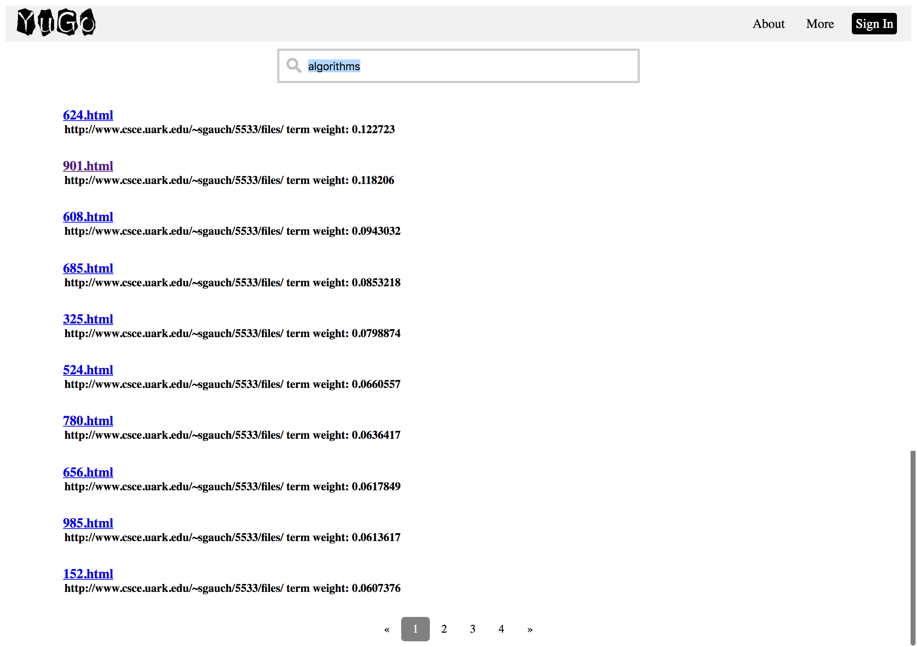

* paradigms algorithms

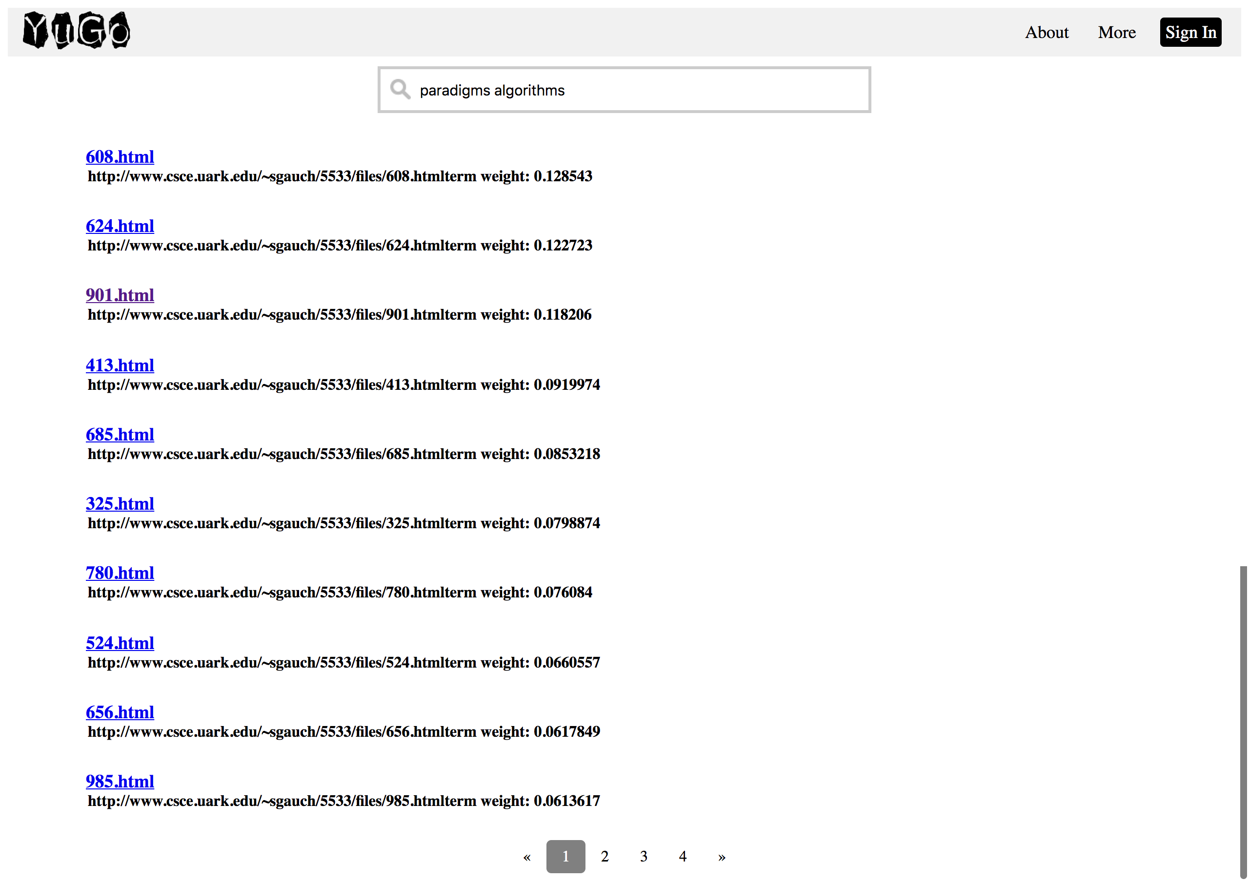

* Gauch // Assume the simple and hard html are there

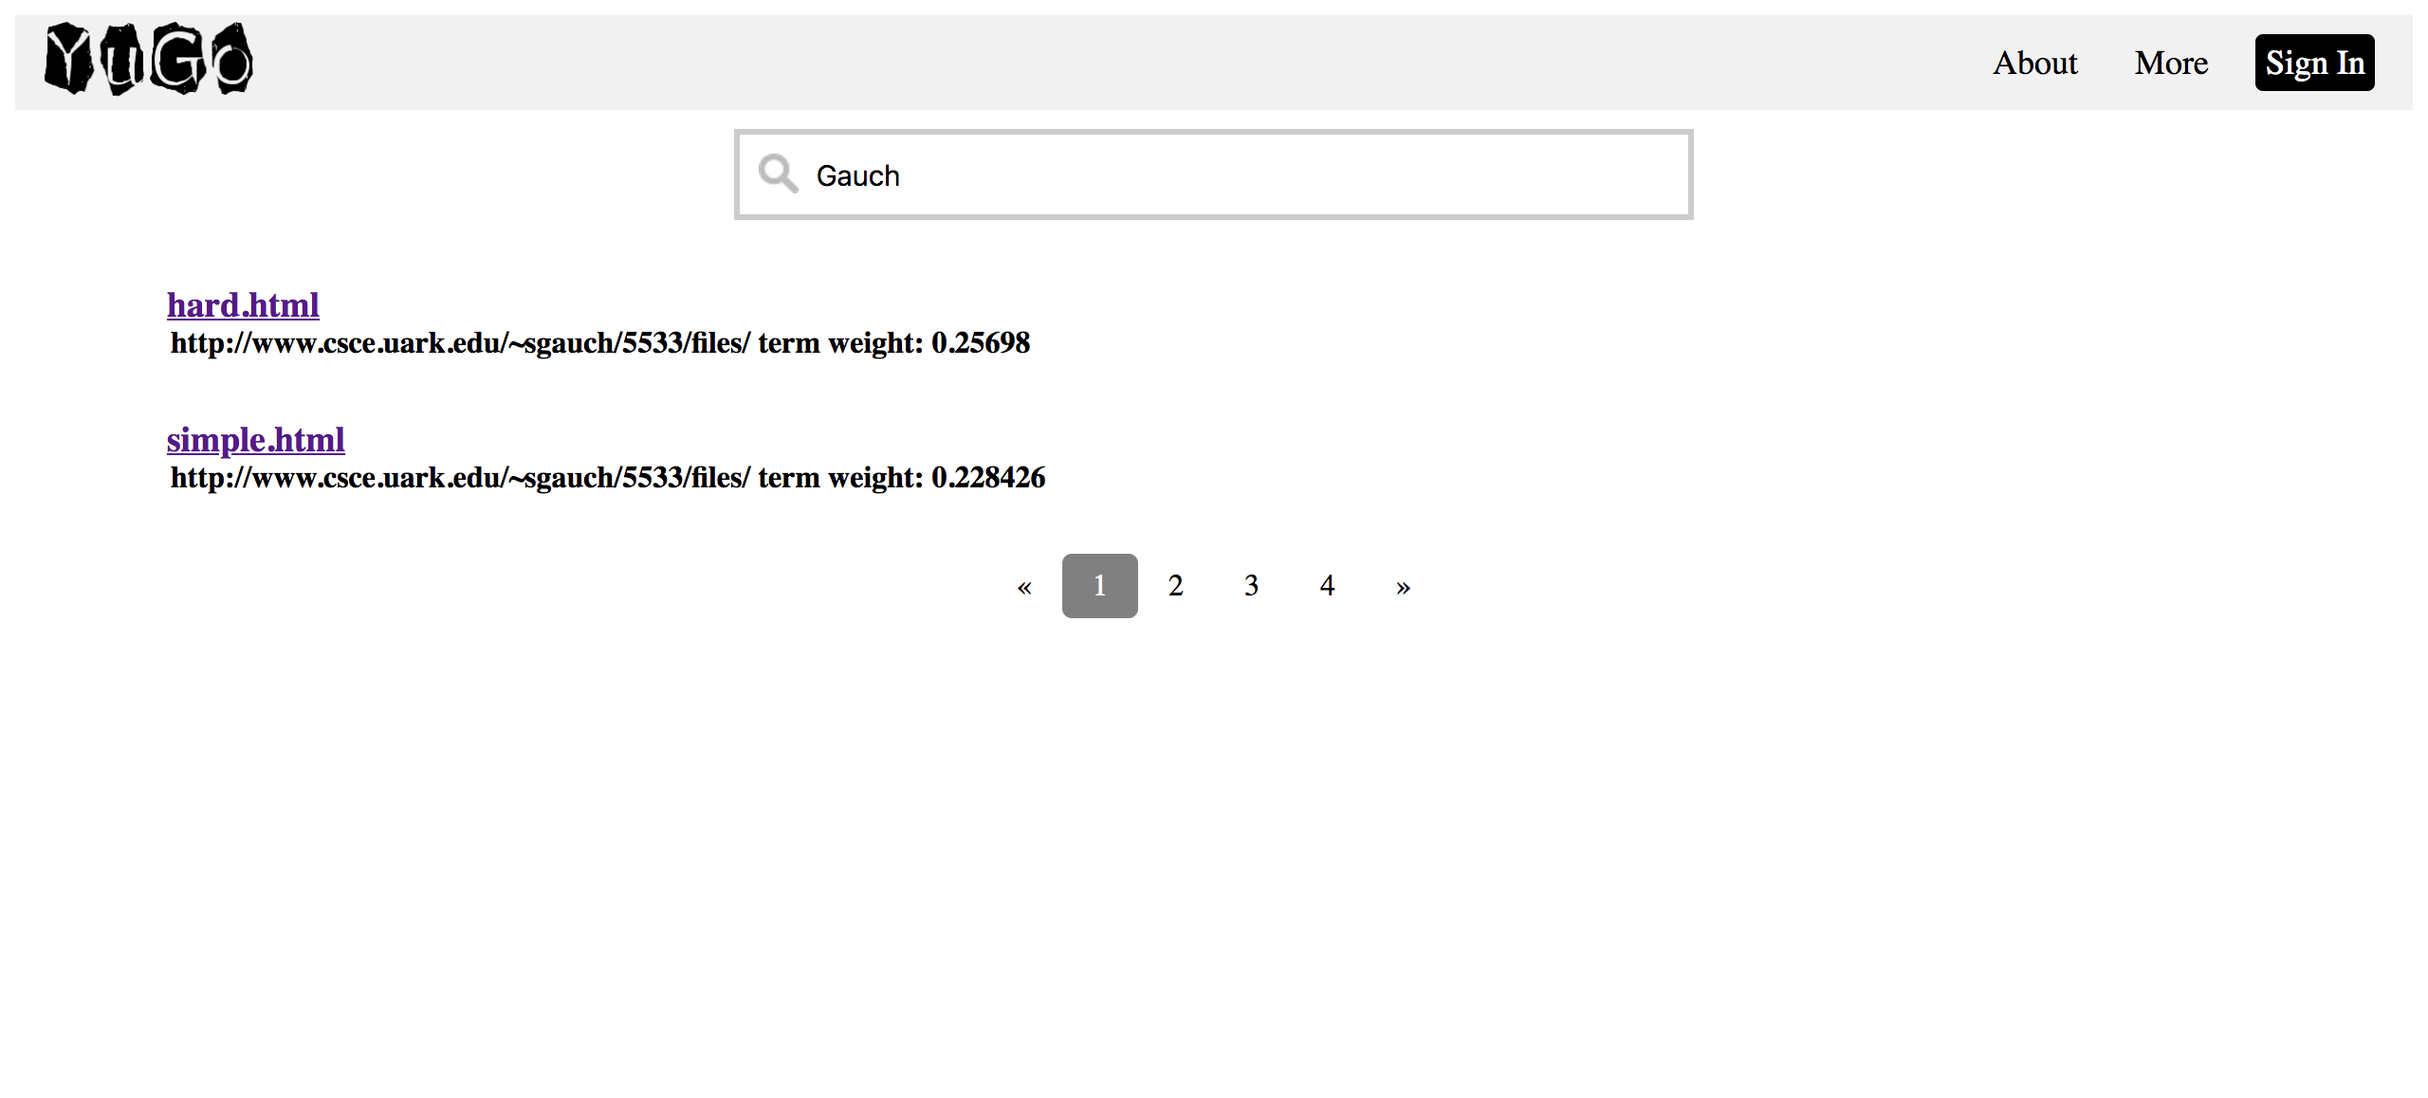

* Michael

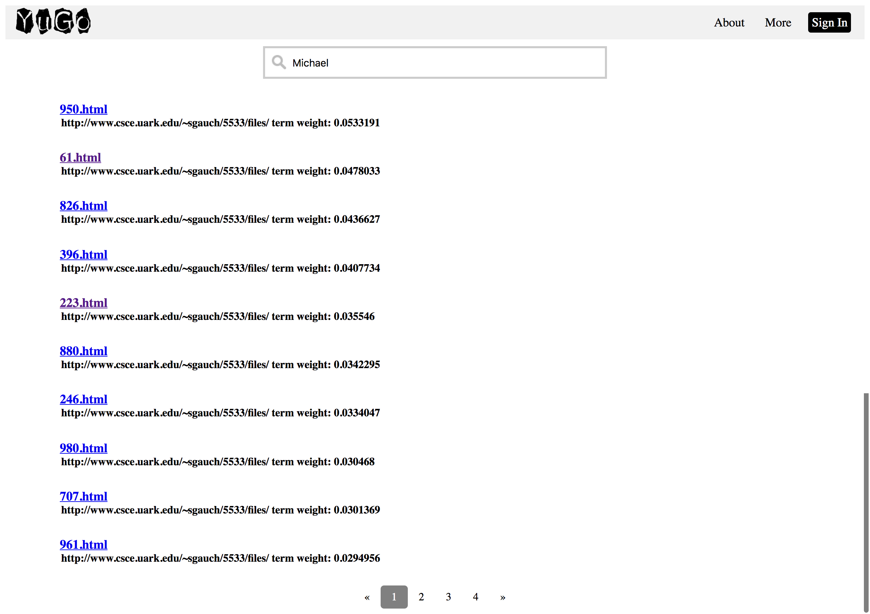

* Scott

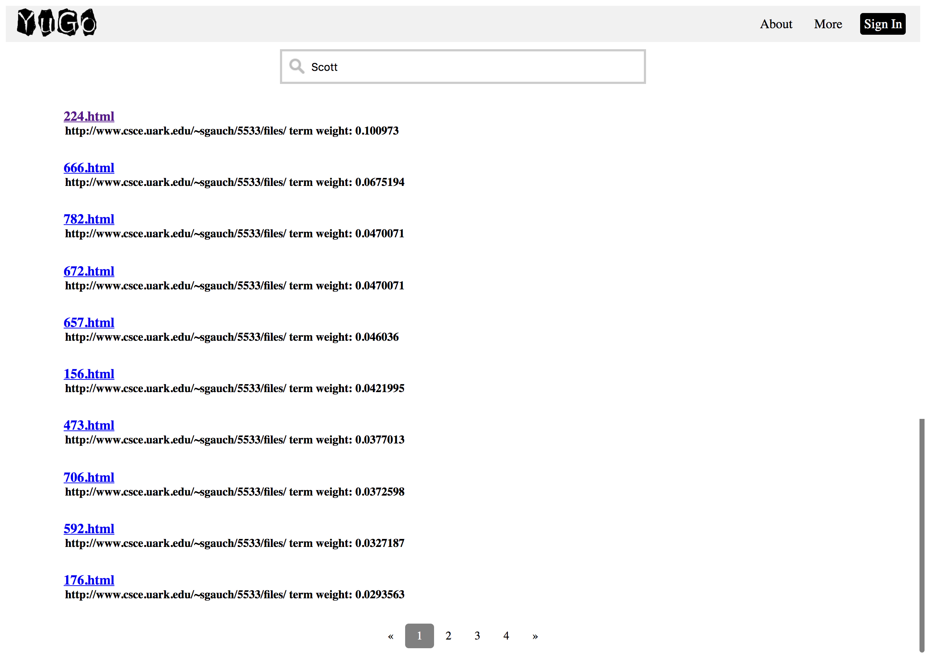

* Michael Scott

